

**New KOCT PSA**

**DATE:** January 31, 2018

**CONTACT:** Tom Reeser

Executive Director

**PHONE:** (760) 722-4433

**EMAIL:**  [koct@koct.org](mailto:koct@koct.org)

**KOCT NEWS RELEASE**

**FOR IMMEDIATE RELEASE**

**Oceanside Public Library Big Read**

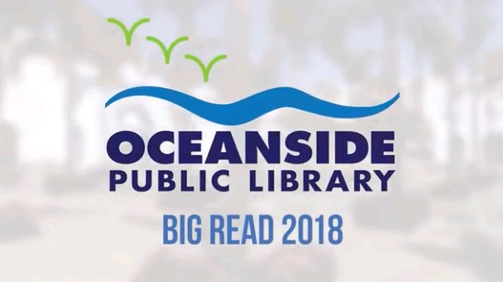

**KOCT has completed a new public service announcement that showcases the Oceanside Public Library’s Big Read Event.**

**Please click** [HERE](http://koct.org/video/category/koct_promos/detail/2018_big_read) **to view this PSA.**

**Watch this PSA, and many others, by visiting KOCT.org’s** [**Video on Demand.**](http://koct.org/video)

Viewers in Oceanside can watch KOCT via Cox Cable on Channels 18 & 19, as well as, county-wide on AT&T’s U-Verse service (Channel 99). Stream programing live on [**KOCT.org**](http://koct.org) to stay connected with your community by tuning into KOCT-North County’s Channels!